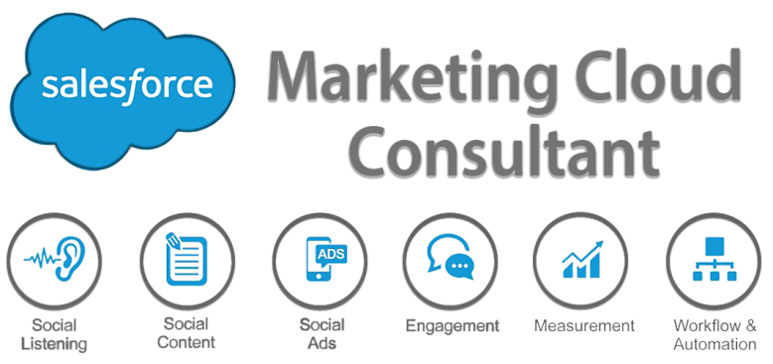

1. **Discovery**

* Provided with a set of business requirements, determine what additional information is needed to design the recommended solution.
* Provided with a list of branding and creative strategies, probe for additional information that is needed to recommend an appropriate solution.
* Provided a customer environment and goals, determine the viability of external systems that need to be included in the solution (I.e. POS, CRM, ecommerce, data warehouse, data source inputs).
* Demonstrate how to gather requirements in order to put together the data and segmentation strategy for the customer (I.e. frequency, complexity, volume of sending).
* Given a scenario that includes customer information about subscriber acquisition, management, and attrition, utilizes this information to select solution components.
* Given a solution, recommend the appropriate customer skill sets required to utilize the Marketing Cloud application.

1. **Conceptual Design**

* Analyze customer data to determine the appropriate data model (I.e. List model, Data Extensions).
* In a given scenario, determine appropriate solution for given requirements considering technical expertise of personas (I.e. Automation Studio vs. Journey Builder).
* In a given narrative data flow, select the correct data flow diagram that depicts that data flow.
* In a given customer scenario, identify which User Stories are appropriate to use for accessing Marketing Cloud.
* In a given customer scenario, determine factors to consider when scaling the solution.
* Articulate how data construct will drive one-to-one messaging and content.
* Explain the purpose of IP Warming and make a recommendation based on customer needs.

1. **Marketing Cloud Connect**

* Understand the prerequisites to consider prior to starting a Marketing Cloud Connect configuration (I.e. Salesforce edition, list of integration users, scope user, administrator credentials).
* Understand how to send an email to a contact, lead, campaign, and report via the Sales / Service Cloud and Marketing Cloud (I.e. sending, triggered, automated).
* Understand how Sales / Service Cloud data in the Marketing Cloud can be segmented.

1. **Account Configuration**

* Given a customer scenario, recommend the appropriate Marketing Cloud role based on User Stories.
* Determine which type of customer scenario warrants the creation of a business unit (I.e. publication types, demographic, workflow processes, and organizational structure).
* In a given scenario, troubleshoot issues regarding Reply Mail Management.
* Analyze the impact of applying Sender Authentication Package (SAP) to a business unit (I.e. link wrapping, Landing Pages, image URLs).

1. **Reporting**

* Explain how the information in data views and tracking extracts are accessed.
* Compare and contrast standard reports, data views, and tracking extracts.

1. **Data Design**

* Explain the various data objects in the Marketing Cloud (I.e. data extensions, list model, data retention model, publication lists, suppression lists).
* Understand available data types, retention and template options when building a data extension.
* Understand how data is retrieved within a Relational Data Model (I.e. basic SQL).
* Given a customer scenario, recommend appropriate import method with lists or data extensions.
* Understand the implications of a system being database of record.

1. **Automation**

* Given a customer scenario, select the appropriate workflow that meets the business requirement (I.e. import, segmentation, email send).
* Compare and contrast triggered and scheduled interactions.

1. **Email Build**

* Understand the required steps to build, test, and deploy an email based on customer requirements.
* Explain the various ways to individualize email content (I.e. AMPscript, personalization strings, Dynamic Content, Guide Template Language).
* Compare and contrast the ways to individualize content, such as: SSJS vs AMPscript, Dynamic Content Wizard vs. AMPscript/LookupRows function.
* Explain various Marketing Cloud Email technologies (I.e. Link Alias tags, Impression regions, Web Analytics Connector).

1. **Contact Builder**

* Explain the role and capabilities within Contact Builder.
* Understand how cardinality impacts data modeling.
* Summarize how to use Data Designer to incorporate data source into Contact Builder.
* Given a customer scenario, know how to build an Attribute Group to be used for a simple interaction.

1. **Journey Builder**

* Compare and contrast automation tools, such as Journey Builder and Automation Studio.
* Given a customer scenario that includes Journey Builder, evaluate the requirements, activities, and steps.
* Explain the requirements for and the methods by which a contact can enter a Journey.